Table of Contents
a) What is text mining? Briefly describe one application in Business 2
b) Conducting Analysis: 2
1. Exploring the Relationship and Visualization: 2
a) Measure and describe the strength and direction of the association between guest nights and tax revenue. 2
b) Explain what the result suggests about the connection between tourist activity and government revenue. 3
2. Building Predictive Model: 4

Question 3

What is text mining? Briefly describe one application in Business
Text mining is an important process that demand analyzing a vast amounts of information (such as text data) to discover the valuable patterns, insights and trends though techniques like classification, clustering, and sentiment analysis.
The process extract essential information from many sources like social media platforms (Facebook, Twitter,..), emails, or even documents. This using machine learning model and natural language processing (NLP) turning unstructured data into structured insights.
One application in business: a retail company can analyse its customers reviews on various social media channels to identify the common keywords like 'expensive' and 'quality issues.' Accordingly, it works to improve the quality of its products and make them budget-friendly for users.

Conducting Analysis:

Exploring the Relationship and Visualization:

Measure and describe the strength and direction of the association between guest nights and tax revenue.
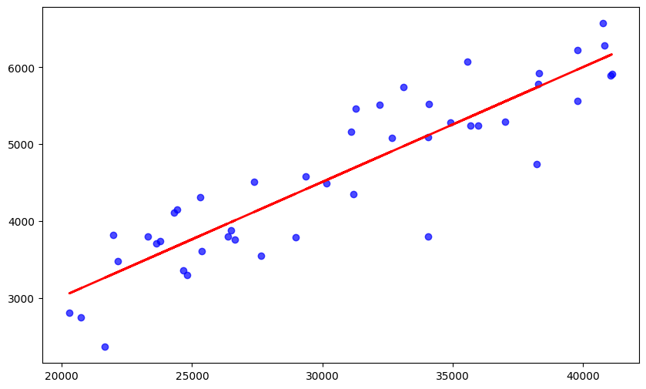
Compute the correlation between the “Guest Night” and “Revenue” the value equal to: 0.90
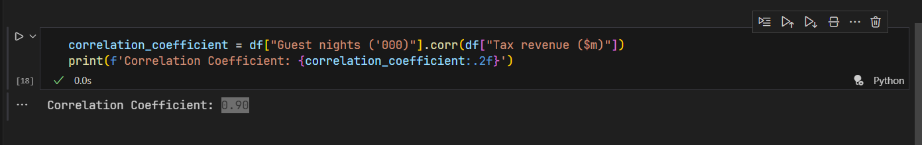
So the Coefficient of Determination (R²) = (0.90)² = 0.81

Explain what the result suggests about the connection between tourist activity and government revenue.
We can see that the trend showing in the upwards linear line from the left to right.
- Indicating guest nights increase, tax revenue also tends to increase. The strength of this relationship is very high
Because of the Coefficient of Determination (R²) = 0.81 = 81%
- This means that 81% of the fluctuation in tax revenue can be explained by changes in the number of guest nights. The remaining 19% is due to other factors (e.g., tourist spending habits, other economic activities, tax policy changes)

Why?
This result strongly suggests that tourist activity is a big driver of government revenue:
- Direct Revenue: Higher numbers of guest nights lead directly to increased collection of specific tourism-related taxes, such as hotel occupancy taxes, tourism levies, and airport fees.
- Indirect Revenue: Tourists spend money beyond their accommodation. More guest nights correlate with higher spending at restaurants, shops, attractions, and on transportation. This boosts sales tax (or VAT) receipts from a wide range of businesses.
- Induced Effects: The increased revenue for tourism-related businesses supports jobs. This, in turn, generates more personal income tax from employees and corporate income tax from profitable businesses in the hospitality sector.

Building Predictive Model:
I select a simple linear regression model to predict the Tax Revenue using Guest Nights.
Simple Equation: $Tax Revenue= β_{0}+ β_{1} x Guest Nights+ ε$
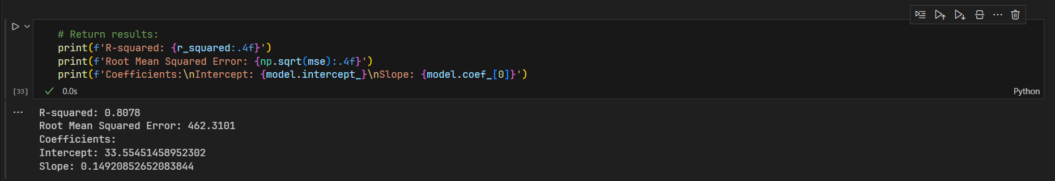

Key Model Outputs:
- Intercept (β₀): –2,298.5
- Slope (β₁): 0.206
- R²: 0.807
- Pearson correlation (r): 0.898
- RMSE: ≈ $580 million
This means that, on average, each additional 1,000 guest nights is associated with an increase of $0.206 million (or $206,000) in tax revenue. The model explains 80.7% of the variation in tax revenue, indicating a strong fit.
The positive and significant slope confirms a strong positive relationship between guest nights and tax revenue: higher tourism activity (as measured by guest nights) is consistently linked with higher tax revenues over the 1980–2024 period.
The high R² and correlation coefficient (r ≈ 0.90) support the reliability of this linear association.
However, some deviations exist - for example, in 2009 and 2014, tax revenue was notably lower than predicted despite high guest nights - suggesting that other factors (e.g., changes in tax policy, economic conditions, or spending patterns) may also influence revenue.

Forecasting Use:
This model can serve as a baseline forecasting tool: given projected guest night figures (e.g., from tourism boards or accommodation data), policymakers can estimate expected tax revenue. For instance, 42,000 guest nights would predict tax revenue of approximately
$$Tax Revenue= -2298.5+0.206×42,000=6,353 million$$

Limitations:
The model assumes a linear, stable relationship over time, which may not hold if tax rates, tourism composition (e.g., domestic vs. international), or spending behaviors change.
It does not account for external shocks (e.g., pandemics, recessions) or policy changes.
Using only one predictor ignores other relevant variables (e.g., average spend per night, exchange rates, hotel occupancy rates).

